Practical 1:

Exploring Ethical Case Studies in AI Systems Using Python

Aim:To explore an ethical case study of an AI-based student selection system and identify possible issues related to bias and fairness.

Problem Statement
Consider an AI system that selects students for a program based on their scores. We will examine whether the selection results are fair across different genders.

Dataset
Student | Gender | Score | Decision
Asha | F | 85 | Selected
Rahul | M | 80 | Selected
Priya | F | 90 | Selected
Amit | M | 75 | Rejected
Neha | F | 82 | Selected
Vikas | M | 88 | Selected

Python Program
# Practical: Exploring Ethical Case Studies in AI Systems
import pandas as pd
# Create dataset
data = {
"Student": ["Asha", "Rahul", "Priya", "Amit", "Neha", "Vikas"],
"Gender": ["F", "M", "F", "M", "F", "M"],
"Score": [85, 80, 90, 75, 82, 88]
}

df = pd.DataFrame(data)

# AI selection rule
# Students with score >= 80 are selected
df["Decision"] = df["Score"].apply(
lambda x: "Selected" if x >= 80 else "Rejected"
)

print("Student Selection Results:")
print(df)

# Calculate selection rate for each gender
selection_rate = df.groupby("Gender")["Decision"].apply(
lambda x: (x == "Selected").mean() * 100
)

print("\nSelection Rate by Gender:")
print(selection_rate)

# Display selected and rejected students
print("\nSelected Students:")
print(df[df["Decision"] == "Selected"])

print("\nRejected Students:")
print(df[df["Decision"] == "Rejected"])

Expected Output
Student Selection Results:

Student Gender Score Decision
0 Asha F 85 Selected
1 Rahul M 80 Selected
2 Priya F 90 Selected
3 Amit M 75 Rejected
4 Neha F 82 Selected
5 Vikas M 88 Selected

Selection Rate by Gender:

Gender
F 100.000000
M 66.666667

Practical 2: Identifying Bias in Datasets Using Python

Aim:To identify gender, race, and age imbalance in a dataset using Python.

Python Code
import pandas as pd
import matplotlib.pyplot as plt

# Create sample dataset
data = {
"Gender": ["F", "M", "F", "M", "F", "M", "F", "M"],
"Age": [22, 25, 23, 45, 24, 46, 21, 50],
"Race": ["Asian", "Asian", "Asian", "White",
"Asian", "White", "Black", "White"]
}

df = pd.DataFrame(data)

# Check gender distribution
print("Gender Distribution:")
print(df["Gender"].value_counts())

# Check race distribution
print("\nRace Distribution:")
print(df["Race"].value_counts())

# Check age statistics
print("\nAge Statistics:")
print(df["Age"].describe())

# Visualize race distribution
df["Race"].value_counts().plot(kind="bar")
plt.title("Race Distribution")
plt.xlabel("Race")
plt.ylabel("Number of People")
plt.show()

Explanation
- Create Dataset:
A sample dataset containing Gender, Age, and Race is created.
- value_counts()
Counts how many people belong to each gender or race group.
df["Race"].value_counts()
This helps identify unequal representation.
- describe()
Provides age statistics such as mean, minimum, maximum, and standard deviation.
df["Age"].describe()
- Visualization:
A bar chart makes demographic imbalance easier to identify.

Observation
The dataset has equal male and female representation, but the race distribution is unequal. The Black group has fewer records than the Asian and White groups. This may indicate dataset imbalance, although imbalance alone does not prove algorithmic bias.

Bias Mitigation
- Collect more representative data.
- Balance underrepresented groups.
- Check fairness metrics.
- Review biased features.
- Regularly audit the AI model.

Conclusion
Python can help identify potential bias and demographic imbalance using summary statistics and visualizations.

Practical 3: Measuring Fairness in AI Models Using Python

Aim:To measure fairness in an AI model using Demographic Parity and Equal Opportunity.

Python Code
import pandas as pd

# Sample AI model results
data = {
"Gender": ["F", "F", "F", "M", "M", "M"],
"Actual": [1, 1, 0, 1, 1, 0],
"Predicted":[1, 1, 1, 1, 0, 0]
}

df = pd.DataFrame(data)

# Demographic Parity
# Selection rate = number predicted positive / total
dp = df.groupby("Gender")["Predicted"].mean()

print("Demographic Parity:")
print(dp)

# Equal Opportunity
# True Positive Rate = TP / Actual Positive
eo = df.groupby("Gender").apply(
lambda x: x[x["Actual"] == 1]["Predicted"].mean()
)

print("\nEqual Opportunity (TPR):")
print(eo)

Explanation
1. Demographic Parity
It checks whether different groups receive positive predictions at similar rates.
Formula:
Selection Rate = Positive Predictions / Total Predictions
If the selection rates of groups are very different, there may be a fairness concern.
2. Equal Opportunity
It checks whether qualified people from different groups have similar chances of being correctly selected.
Formula:
TPR = True Positives / Actual Positives

Expected Output
Demographic Parity:
Gender
F 1.000000
M 0.333333

Equal Opportunity (TPR):
Gender
F 1.000000
M 0.500000

Observation
The model gives different outcomes for males and females in this small sample. Therefore, the results should be investigated further for possible fairness issues.

Conclusion
Python can be used to compare AI model outcomes across demographic groups using fairness metrics such as Demographic Parity and Equal Opportunity.

Practical 4:

AI Stakeholder Mapping Using Python

Aim:To identify stakeholders involved in an AI-based smart surveillance system and understand their ethical responsibilities.

Python Code
import pandas as pd

# Stakeholder mapping
data = {
"Stakeholder": [
"Government",
"AI Developer",
"Police",
"Citizens",
"Technology Company"
],
"Responsibility": [
"Ensure legal and ethical use",
"Develop accurate and fair AI",
"Use the system responsibly",
"Protect privacy and report misuse",
"Protect data and system security"
]
}

df = pd.DataFrame(data)

print("AI Stakeholder Map:\n")
print(df.to_string(index=False))

Explanation
- Government: Creates rules and ensures lawful and ethical use of AI.
- AI Developer: Develops a fair, accurate, and transparent system.
- Police: Uses AI responsibly and verifies AI results before taking action.
- Citizens: Have privacy rights and should be informed about surveillance.
- Technology Company: Protects personal data and maintains system security.

Expected Output
AI Stakeholder Map:

Stakeholder Responsibility
Government Ensure legal and ethical use
AI Developer Develop accurate and fair AI
Police Use the system responsibly
Citizens Protect privacy and report misuse
Technology Company Protect data and system security

Conclusion
Stakeholder mapping helps identify who is affected by an AI system and who is responsible for its ethical use.

Practical 5: Designing Ethical AI Systems Using Python

Aim:To design a simple AI-based education support system and identify its ethical principles, risks, and mitigation strategies.

Python Code
import pandas as pd

# Simple AI system for identifying students needing support
data = {
"Student": ["Asha", "Rahul", "Priya", "Amit"],
"Attendance": [90, 60, 85, 55],
"Marks": [80, 45, 75, 40]
}

df = pd.DataFrame(data)

# AI rule: recommend support if attendance < 75 OR marks < 50
df["Support_Required"] = (
(df["Attendance"] < 75) | (df["Marks"] < 50)
)

print(df)

Explanation
The system identifies students who may need additional academic support using attendance and marks.
- Privacy: Student data should be protected.
- Fairness: The system should not discriminate against any group.
- Transparency: Students and teachers should understand why support was recommended.
- Human Oversight: Teachers should verify AI recommendations before taking action.

Potential Risks & Mitigation
Risk | Mitigation
Incorrect prediction | Teacher verification
Privacy violation | Protect and anonymize data
Bias | Regular fairness testing
Wrong decision | Keep human in the loop

Conclusion
Ethical AI should be designed with fairness, privacy, transparency, security, and human oversight from the beginning.

Practical 6:

Visualize Data Using Basic Plotting Techniques

Aim:To visualize data using bar chart, line chart, and scatter plot in Python.

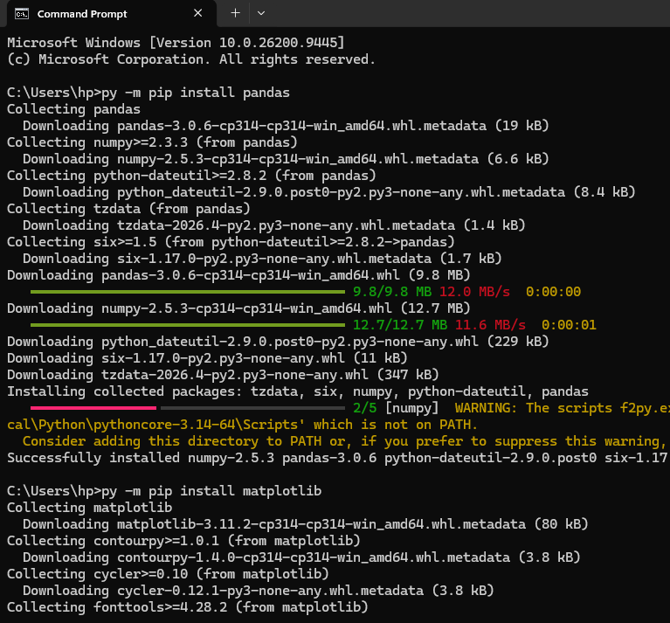

Python Code
import matplotlib.pyplot as plt

# Sample data
students = ["Asha", "Rahul", "Priya", "Amit", "Neha"]
marks = [85, 70, 90, 65, 80]

# Bar Chart
plt.bar(students, marks)
plt.title("Student Marks")
plt.xlabel("Students")
plt.ylabel("Marks")
plt.show()

# Line Chart
plt.plot(students, marks, marker="o")
plt.title("Student Marks - Line Chart")
plt.xlabel("Students")
plt.ylabel("Marks")
plt.show()

# Scatter Plot
plt.scatter(students, marks)
plt.title("Student Marks - Scatter Plot")
plt.xlabel("Students")
plt.ylabel("Marks")
plt.show()

Explanation
- Bar Chart: Compares marks of different students.
- Line Chart: Shows the pattern or change in marks.
- Scatter Plot: Displays the relationship between two variables.
- plt.title() → Adds chart title.
- plt.xlabel() → Labels X-axis.
- plt.ylabel() → Labels Y-axis.
- plt.show() → Displays the graph.

Conclusion
Matplotlib helps to visually represent data, making comparisons, patterns, and relationships easier to understand.

Practical 7:

Data Privacy – GDPR Concept

Aim
To demonstrate how personal information can be protected using Python
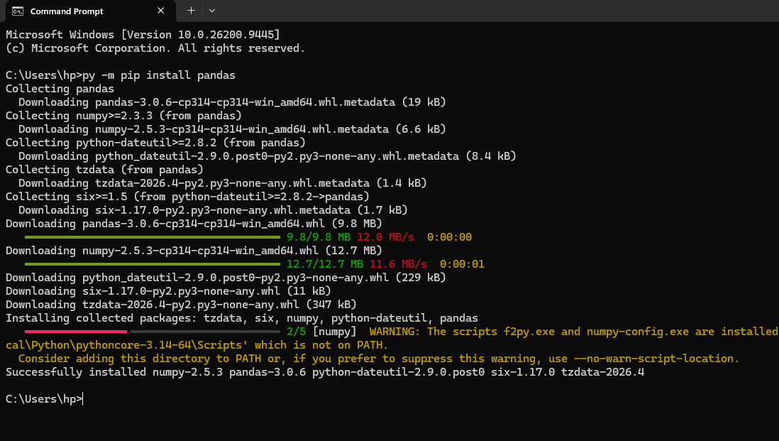.

Easy Python Code

import pandas as pd

# Create student data

data = {

"Name": ["Asha", "Rahul", "Priya"],

"Age": [20, 21, 20],

"Marks": [85, 78, 90]

}

# Create DataFrame

df = pd.DataFrame(data)

# Display original data

print("Original Data:")

print(df)

# Remove personal information

df = df.drop("Name", axis=1)

# Display protected data

print("\nProtected Data:")

print(df)

Explanation
- Name is personal information.
- drop() removes the Name column.
- Only necessary data such as Age and Marks is retained.
- This demonstrates the basic idea of data minimization and privacy.

Conclusion
Personal information should be protected and only necessary data should be used when designing responsible AI systems.

